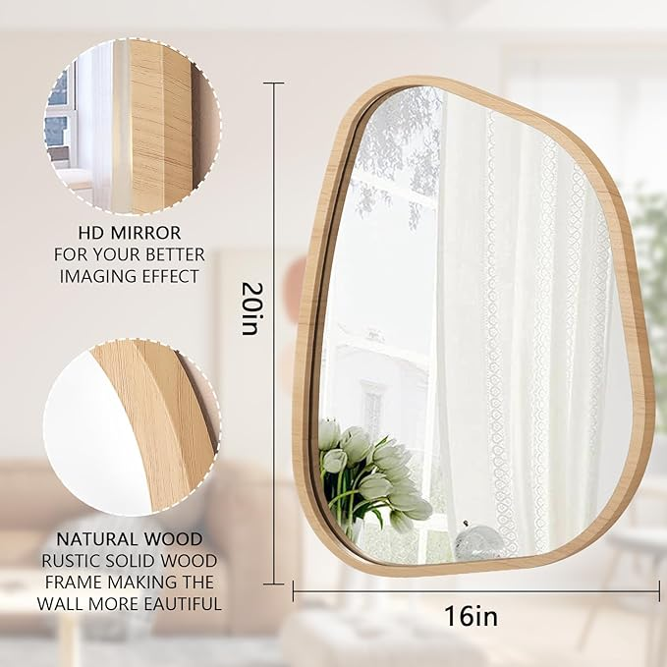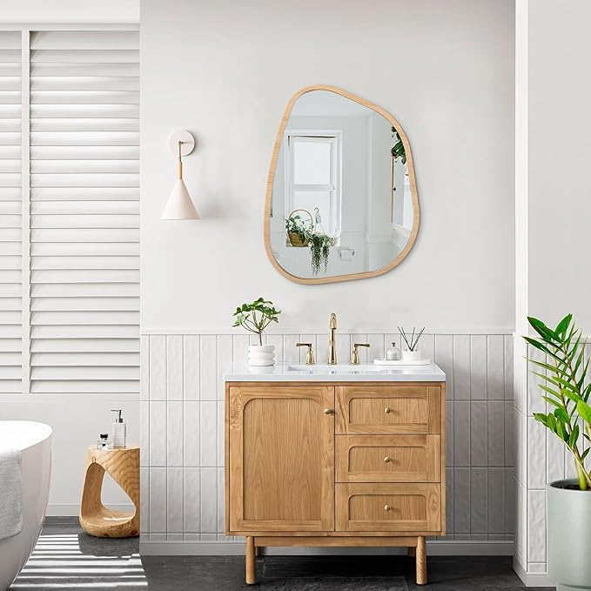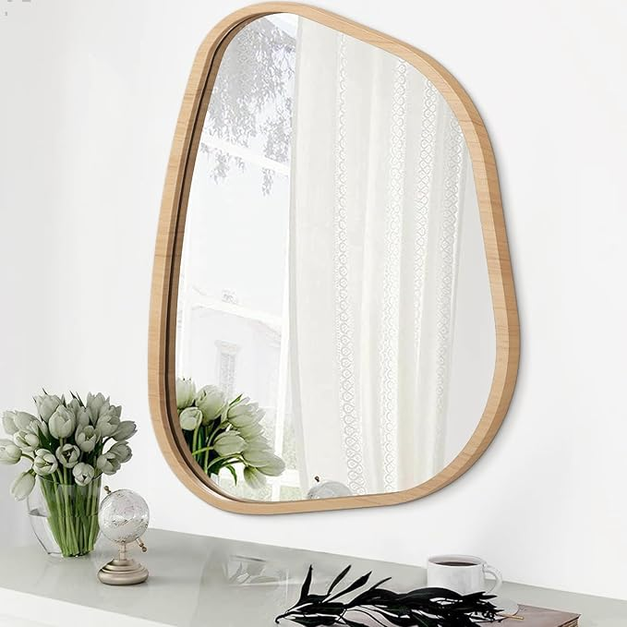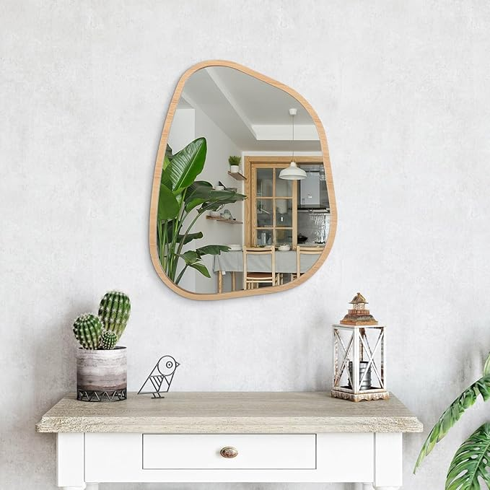

Asymmetrical Irregular Mirror Wall Mounted, Unique Vanity Mirror, Shaped Dressing Boho Mirror Decorative for Living Room, Bathroom, Bedroom, Entryway Wall Decor 20"x16"

**PRODUCT DESCRIPTION:**

|  |  |
| --- | --- |
| Brand | HLFMVWE |
| Room Type | Entryway, Bathroom, Bedroom, Living Room |
| Shape | Irregular |
| Product Dimensions | 20"L x 16"W |
| Frame Material | Wood |

**About this item**

* Unique And Design : This irregularly oval shaped mirror is a wall decoration. The modern asymmetrical design is an artistic display in itself, both simple and sophisticated, for the living room, bedroom or hallway
* Size And Installation : This asymmetrical mirror Available in a variety of sizes. When hanging the wall, hooks are pre-installed behind the backboard, the package includes screws, It is easy to install and hang
* HD Mirror Material: High quality float glass is used to make mirrors to ensure more clear and realistic images. Wood frame, elegant black. simpler and more textured, durable and colorfast. No odor, safe and environmentally friendly
* Wooden Frame : We chose wood as the frame material, which has a modern look. The frame is handcrafted to add a modern and artist feel to beautify your home. Asymmetrical wall mirrors are perfect home decor for bedrooms, living rooms, entryways
* Sturdy : The glass mirror is fixedly embedded in the frame and reinforced with a solid backrest, which increases the stability, and the material is thickened to make the structure strong and durable